Introduction
SpecterX lets you control email protection features by adding special headers to your emails. For cases where adding custom headers isn’t possible—like when using CRMs, ERPs, or other 3rd party tools—you can also embed these parameters in the email subject. This gives you flexibility whether you’re sending emails directly, using automated workflows, or integrating with external systems.

How to Use the Headers

Option 1: As Standard SMTP Headers
Add these as custom headers when sending your email programmatically (via SMTP, API, etc).

Example (using SMTP headers):
x-specterx-userphone: +972526212075
x-specterx-protection-type: All
x-specterx-policy-id: a8ad41a6-05ea-4dc5-97f6-c4c6cac076b0


Option 2: In the Email Subject
If your system doesn’t let you add custom SMTP headers (common with Salesforce, ERP, etc.), you can pass the same parameters directly in the email’s subject line.
Formatting Rules:
- Place parameters between # symbols anywhere in the subject.
- It’s possible to use one or more parameters in the same subject.
- Use commas to separate multiple key-value pairs.
- The keys are case-insensitive.
- Phone numbers support spaces and dashes.
- Format: #Key1=Value1,Key2=Value2#
- You can mix them with normal subject text - only the parameters in #...# are parsed.
Example (using Subject parameters):
Some subject words #x-specterx-userphone=+972 50 123 4567,x-specterx-policy-id: a8ad41a6-05ea-4dc5-97f6-c4c6cac076b0 # more subject words


When Policy Requires Phone Number Verification
If the chosen policy (via x-specterx-policy-id) requires recipient phone number verification, SpecterX must have the recipient’s phone number.
- If no Policy ID is provided, the default SpecterX policy will be used.
- If the phone number is not already known to SpecterX and not provided in the email (either as a header or in the subject), the email will not be delivered.
- In this case, the failure is logged for auditing and a notification is sent to the sender.

Expectation rule
To avoid a loop and sending an already protected to SpecterX MPS
over and over again, we need to set an expectation rule.
Set “Except if” to “The message headers” - “matches these text patterns”.
Then set the header key to x-specterx-policy and the value to protected.
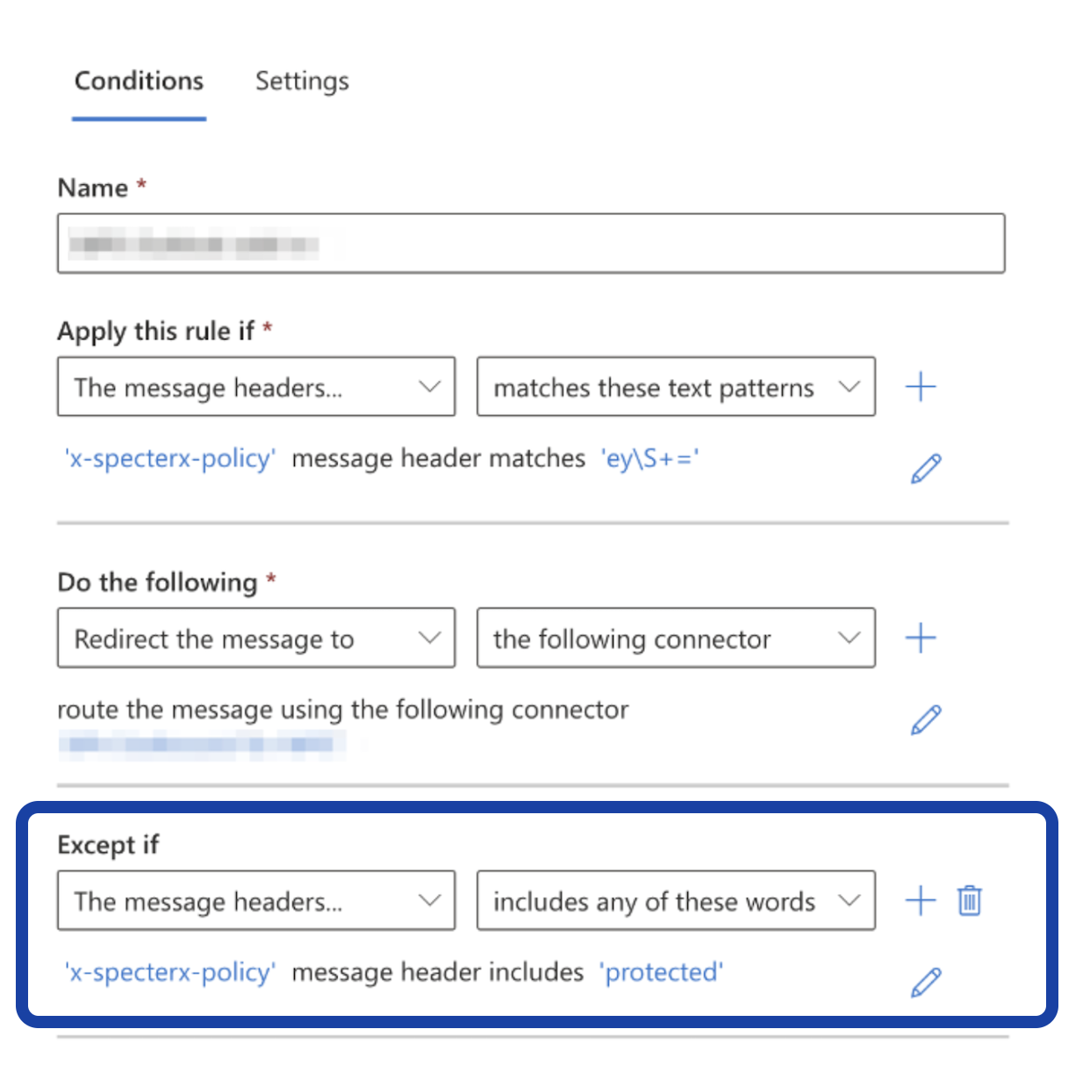

SpecterX Mail Protection Service - Supported Headers

Header Description | Header Key and Aliases | Values
Source application identifier. Used as the “app name” in the audit logs. | Header Key:  x-specterx-appid  Accepted Aliases:  X-PRIVAWALL-KEY | <value>********</value>  or  <value>key=********</value>  Where ******** stands for the AppID
The recipient’s phone number.  In case of a single recipient, this value will be assigned as that user’s phone number in SpecterX.  If there is more than one user specified as a recipient of this email, the service will stop processing this email. | Header Key:  x-specterx-userphone  Accepted Aliases:  X-PG_Mobile | <value>0526212075</value>  or any other acceptable phone format (with/without dashes, with/without country code, etc).
A password that will be used to encrypt the received files upon downloading them.  In case of a single recipient, this value will be assigned as that user’s phone number in SpecterX.  If there is more than one user specified as a recipient of this email, the service will stop processing this email. | Header Key:  x-specterx-  encryptionpass  Accepted Aliases:  - | Same as AppID
A value determining if protection should be applied, and what should be protected (body / attachments). | Header Key:  x-specterx-  protection-type  Accepted Aliases:  X-PG_Enc | To protect the entire email, including both the email body and its attachments, use:  <value>All</value> or <value>EnvelopePdf</value>  To protect only the email’s attachments, and leave the email body in plain text, use:  <value>Attachments</value> or <value>OuterPdf</value>  To not protect the email at all, leave this parameter missing, empty, or set to ‘None’, like so:  <value>None</value>
Determines the policy applied to this message and its attachments. | Header Key:  x-specterx-policy-id  Accepted Aliases:  X-PG_Enc | <value>a8ad41a6-05ea-4dc5-97f6-c4c6cac076b0</value>  Where the ID determines the SpecterX Policy to be used.
Users choices given through the SpecterX Outlook Add-in.  Includes information about policies and recipient file-permission levels for the attached files, as well as any phone numbers provided by the sender about the recipients. | Header Key:  x-specterx-policy  Accepted Aliases:  - | Not to be confused with policy-id, this header is generated automatically by our Add-in.  Note: If this header is used, the information given in it will take priority over the other headers.

